**Project Design Phase-II**

**Data Flow Diagram & User Stories**

|  |  |
| --- | --- |
| Date | 26-06-2025 |
| Team ID | LTVIP2025TMID48676 |
| Project Name | Cosmetic Insights |
| Maximum Marks | 4 Marks |

**Data Flow Diagrams:**

A Data Flow Diagram (DFD) is a traditional visual representation of the information flows within a system. A neat and clear DFD can depict the right amount of the system requirement graphically. It shows how data enters and leaves the system, what changes the information, and where data is stored.

**Example:**

**Flow DFD Level 0 (Industry Standard)**

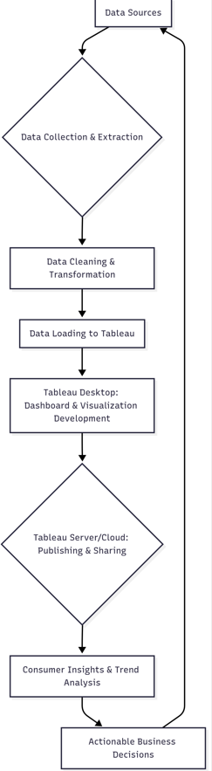 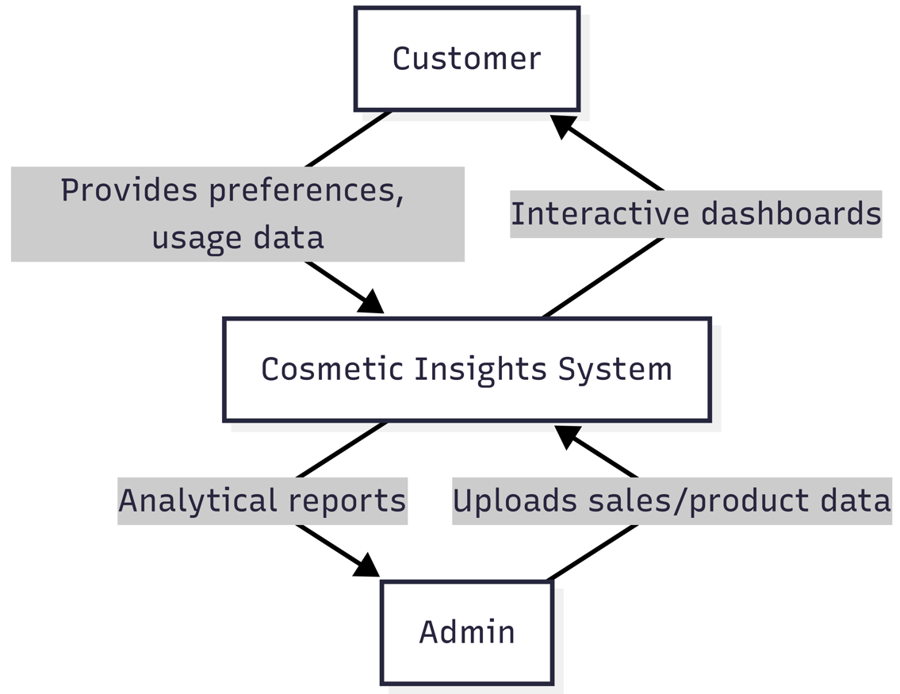

**User Stories**

Use the below template to list all the user stories for the product.

|  |  |  |  |  |  |  |
| --- | --- | --- | --- | --- | --- | --- |
| **User Type** | **Functional Requirement (Epic)** | **User Story Number** | **User Story / Task** | **Acceptance criteria** | **Priority** | **Release** |
| Data Analyst | Dashboard Access | USN-1 | As a user, I can log in to access the Tableau dashboard. | I can securely log in and view insights. | High | Sprint-1 |
| |  | | --- | | Admin |  |  | | --- | |  | | |  | | --- | | Data Upload |  |  | | --- | |  | | USN-2 | As a user, I can compare performance of branches based on revenue and customer count | Bar chart compares branches clearly with sortable metrics | High | Sprint-1 |
| Marketing Manager | Consumer Insights | USN-3 | As a user, I can analyze customer preferences based on purchase trends and ratings | Visual shows top-rated products and frequently purchased categories | High | Sprint-2 |
| Product Manager | Trend Analysis | USN-4 | As a user, I can view monthly and seasonal trends in cosmetics sales | Seasonal/monthly line chart with product category insights is shown | Medium | Sprint-2 |
| Sales Executive | Funnel Analysis | USN-5 | As a user, I can view the customer journey from product interest to purchase | Funnel chart shows stages and drop-off rates | Low | Sprint-3 |